Training Fiche Template

Title | Stakeholder Management: The EntreComp perspective of "Mobilising Others"
Keywords (meta tag) | Networking and Public Relations, Engagement, involvement and retainment of groups of interest
Provided by | IHF asbl
Language | ENGLISH
Objectives / goals / learning outcomes
After reading this Module you will learn about how to identify key stakeholders, and how to assess their power, influence and interest.
Description
Stakeholder management is the process by which you organize, monitor and improve your relationships with your stakeholders. In this module
In this module you can get new information about different tools to manage relevant stakeholders for your project. In addition we’ll be explored the concept of Mobilizing others, an relevant skills part of the EntreComp framework. In a nutshell its means “inspire” relevant stakeholders who can help you move your idea forward and obtain the support needed to achieve your goals.
Contents arranged in 3 levels
- Stakeholder Management: the EntreComp perspective of "Mobilising Others"
  - Stakeholder management
    - SM, an Introduction
Stakeholder management is the process of maintaining good relationships with the people who have most impact on your work. Communicating with each one in the right way can play a vital part in keeping them "on board".
It pays to remember the old saying, "No man is an island." Why? Because almost every project you work on involves other people. And, chances are, you'll depend on some of them for crucial support, investment and resources.
The way that you manage your stakeholders depends on:
- The size and complexity of your project. You could assess this by comparing it to past projects, by examining the project's milestones, by the amount of resources required, or by the time allocated to it, for example.
- The amount of help you need to achieve the results you want. This could include sponsorship, advice and expert input, physical resources, reviews of material to increase quality, and so on.
- The time you have available to communicate. You need to consider how to manage the time you expect to spend on communication, particularly if your project requires a lot of stakeholder input. It is often better to allocate more time to communicating with stakeholders, rather than trying to "get by" without all the help or input that you need.

1.1.2 Stakeholder Analysis
Stakeholder Analysis is the first step in Stakeholder Management, an important process that successful people use to win support from others
There are three steps to follow in Stakeholder Analysis. First, identify who your stakeholders are. Next, work out their power, influence and interest, so that you know who you should focus on. Finally, develop a good understanding of the most important stakeholders, so that you know how they are likely to respond, and how you can win their support.
When you’ve completed your analysis, you can move on to use stakeholder management to work out how you’ll communicate with each stakeholder.
The three steps of Stakeholder Analysis:
1. Identify Your Stakeholders;
2. Prioritize Your Stakeholders;
3. Understand Your Key Stakeholders;
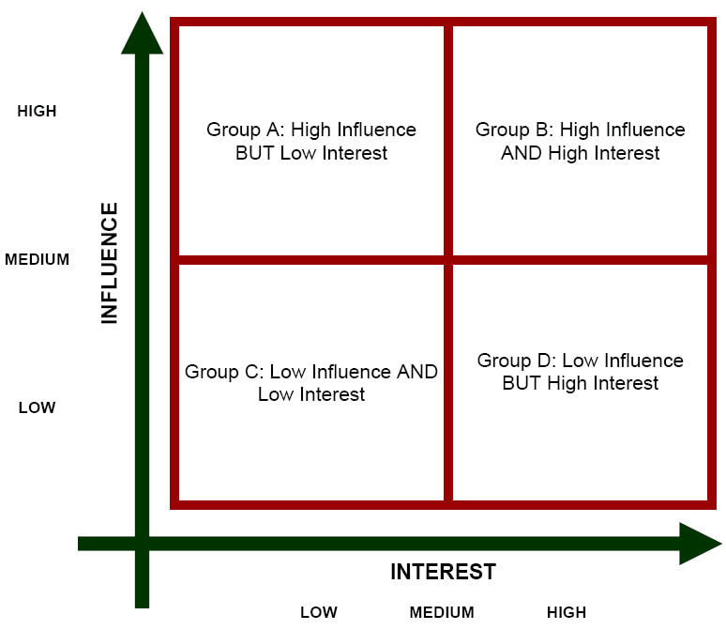
Source: https://www.eldtraining.com/a-trainers-blog/the-four-steps-of-stakeholder-analysis
1.1.3 Stakeholders Assessment Tool
After proper identification of the most relevant stakeholders, the below matrix is used to monitor, assess, and evaluate their current level of engagement compared to desired level.
For high priority stakeholders (i.e. Supportive), a situation like in the case of STKH 1 is much more alarming than the case of STKH 3 – being the fact that an overall resistance / disinterest compromises the efforts of the organisation more than what could do a sense of unawareness.
Clearly, the favourable scenario is when D and C match the same box – which means that the engagement strategies are aligning to expectations.
The Stakeholders Engagement Matrix: Desired (D)/Current (C) engagement:
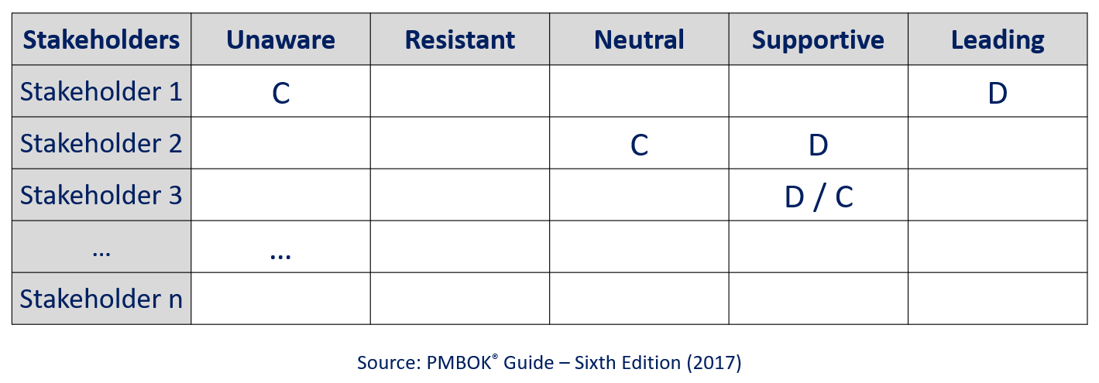
1.2 Mobilizing Others
This skill is part of the EntreComp Framework.
This skill has to do with the ability to inspire and motivate relevant stakeholders to get the support needed in achieving valuable outcomes. One must make sure to demonstrate effective communication, persuasion, negotiation and leadership.

How Mobilizing Others?

1. INSPIRE AND GET INSPIRED!

Inspiration is key to business success. Show enthusiasm for challenges and be actively involved in creating value for others.

2. PERSUADE!
Persuasion is a value creating activity. For instance, in business it consist in selling or trading of a business product, in order to gain profit. The process of persuasion starts with a strong presentation of your idea. Try to understand your listener’s emotions and inspire them to get involved with your idea.
3. COMMUNICATE EFFECTIVELY!
Effective communication is about more than just exchanging information. It’s about understanding the emotion and intentions behind the information. As well as being able to clearly convey a message, you need to also listen in a way that gains the full meaning of what’s being said and makes the other person feel heard and understood.
Here some tips for an effectively communication:
- Become an engaged listener;
- Pay attention to nonverbal signals;
- Keep stress in check;
- Assert yourself.

4. USE MEDIA EFFECTIVELY!
It’s easy to set up a Facebook page and begin posting, but that doesn’t mean it’s easy to effectively use social media. In order to take advantage of social media’s power to reach and motivate large audiences, be strategic and follow these tips:
Plan. Create clear goals and objectives with measures to track progress. Connect your social media goals to your organizational goals. Are you hoping to increase attendance at events? Use Facebook and Twitter to build excitement before events and sustain community engagement between events. Do you want to increase fundraising? Share stories through videos on Youtube to connect with potential donors. Track responses. How many re-tweets? How many shares? Clear goals are important.
Consider your audience. Platform preferences are relatively consistent across generations. Facebook is the most popular platform for sharing content across generations and YouTube is the second most popular. What time do you post? Most people consume content between 8pm-12am, but Baby Boomers are more likely to be online in the morning and Millennials stay up late. Look up information for how to reach your target audience before posting.
Remember that social media is social. Create an interactive online presence. People don’t join networks to be talked at; platforms are supposed to foster conversation. Engage your target audience.. Ask questions, share news stories, and collaborate with other organizations or thought leaders. Listen to others and be social!
Dedicate time to social media. Staff time is the biggest cost of social media, but it is critical to success. Remember that social media can include many people in your organization. Involve your staff who understand your organization’s voice. Having more than one person blogging or tweeting will make your organization more dynamic.
Experiment! Evaluate and adjust your social media strategy until you find what works for your organization. There are applications that allow you to track clicks, shares, and likes so you can understand how people interact with your organization online. Use tools like Facebook Insights to help with these metrics. Don’t get discouraged if you don’t immediately have thousands of followers– creating a strong social media presence takes time! Keep working and be creative! Social media is powerful and if your organization takes advantage of the digital community, you will see results.
Contents in bullet points
Stakeholder management is the process of maintaining good relationships with the people who have most impact on your work. Communicating with each one in the right way can play a vital part in keeping them "on board".
Stakeholder Analysis is the first step in Stakeholder Management, an important process that successful people use to win support from others.
After proper identification of the most relevant stakeholders, the matrix of Stakeholder engagement is used to monitor, assess, and evaluate their current level of engagement compared to desired level.
An important aspect of stakeholder management is the ability to mobilize others with inspiration, persuasion, effective communication and an effective use of the media.
5 glossary entries

Stakeholder Analysis: A stakeholder analysis is a process of identifying these people before the project begins; grouping them according to their levels of participation, interest, and influence in the project; and determining how best to involve and communicate each of these stakeholder groups throughout.
Brainstorming: Brainstorming is a group creativity technique by which efforts are made to find a conclusion for a specific problem by gathering a list of ideas spontaneously contributed by its members. In other words, brainstorming is a situation where a group of people meet to generate new ideas and solutions around a specific domain of interest by removing inhibitions. People are able to think more freely and they suggest as many spontaneous new ideas as possible.
Networking: is the process of trying to meet new people who might be useful to you in your job, often through social activities.
Stakeholder Engagement: Stakeholder engagement is the process used by an organization to engage relevant stakeholders for a clear purpose to achieve agreed outcomes.
EntreComp: is a reference framework for people interested in learning, teaching, and fostering the knowledge, skills, and attitudes that make up an entrepreneurial mindset. EntreComp is a free, open, and flexible tool that can be adapted to your needs.
Bibliography and Further References

MindTools, What Is Stakeholder Management?, What Is Stakeholder Management?
https://www.mindtools.com/pages/article/newPPM_08.htm

Product Plan, Stakeholder Analysis https://www.productplan.com/glossary/stakeholder-analysis/

Help guide, effective Communication, https://www.helpguide.org/articles/relationships-communication/effective-communication.htm

5 ways to use social media more effectively, https://www.nnaac.org/5_ways_to_use_social_media_more_effectively
5 multiple-choice self assessment questions
1) Communication is essential for a good Stakeholder management? T - F
2) How many steps its possible identify for a correct Stakeholder analysis?
1 -3√ - 4
3) What is the purpose of the Stakeholders Assessment Tool?
a. monitor, assess, and evaluate their current level of engagement compared to desired level. √
b. a tool useful to identify indicators and sources
4) Mobilizing Others is part of DigComp. T - F
5) Persuasion is:
a. the act of convincing
b. the act of distract √
Related Material
Related PPT
Reference Link
Video in YouTube format (if any)

