Training Fiche

Title | Digital Marketing and Communication in Agriculture
Keywords (meta tag) | Commodity, branding, Agricultural marketing, Local Marketing,
Provided by | CIRCLE
Language | EN
Objectives / goals / learning outcomes
The aim of this module is to help targets in:
- Get a deeper understanding of the agricultural and food sectors and their marketing
- Familiarise with new skills related to agricultural marketing so as to improve the online visibility and competitiveness of your business
- Acquire new knowledge and practical competences in marketing
Description
- Understand the relevance of marketing to the agricultural and food sectors
- Understand the meaning of the marketing concept
- Understand why it is necessary to implement the marketing concept throughout food and agricultural marketing systems
- Understand the functions of marketing
Contents arranged in 3 levels
1. Marketing in Agriculture
  - An Introduction
By Marketing, we refer to the overall activities, processes and initiatives implemented by the organisation to engage customers’ market and strengthen the attractiveness of the offer.
Marketing is a very analytical activity that combines creative and critical thinking.
1.2 Starting from the Business plan
Like any other company, even farms can take advantage of the many resources that the web offers to make themselves known. And to acquire new customers. On the contrary: generally, agricultural activity lends itself well to storytelling, to telling suggestive stories capable of making the (potential) customer perceive the value of what is being sold.
But how is the marketing plan of an agricultural company drawn up? Definitely, starting from a business plan.
A Business plan might include these following set of key point:
- Business Plan Subtitle;
- Executive Summary;
- Company Description;
- The Business Opportunity;
- Competitive Analysis;
- Target Market;
- Marketing Plan;
- Financial Summary;
- Team;
- Funding Requirements.

1.3 SWOT Analysis
Strengths: What allow us to achieve our objectives?
Weaknesses: What disrupts our efficiency?
Opportunities: What helps us in achieving our objectives?
Threats: What might destabilize our performance?
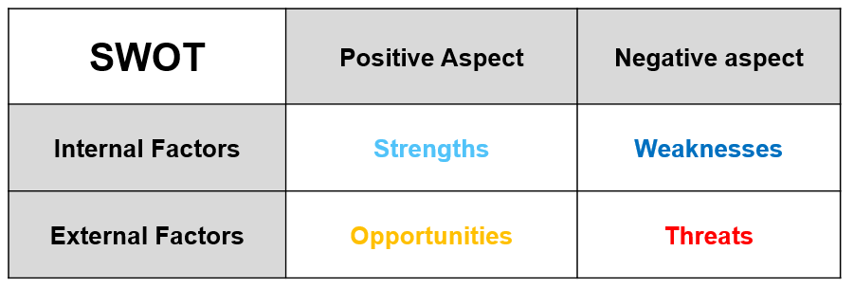
Typical examples of SWOT’s elements:
Strengths: virtual reputation and identity, robust models of internal QA…
Weaknesses: unskilled employees, poor communication and visibility efforts…
Opportunities: high-growth market, new available technology…
Threats: new entrants with robust competences, changes in customers’ preferences, barriers to new, markets…
1.4 Local Digital Marketing
If you do not have an e-commerce and you only sell the products of your farm on site, local marketing is essential.
How to do it?
Other than to the traditional way (advertisements in local newspapers, flyers, organization of events, billboards), the web can be exploited mainly in two ways:
- with sponsored advertisements on Facebook (by selecting a specific kilometre radius);
- working with SEO.
When you organize an event or when you want to promote the typical products you produce, take advantage of all the power and all the visibility that Facebook offers you. But, even before that, write the contents taking into account specific keywords and geo localizing them (e.g., Polish apples, fresh cheese, farmhouse with restaurant).
In addition to that, you must always consider that the user, when looking for something, relies on Google: whether he wants to find a farmhouse with a restaurant to organize his wedding lunch, a farm where your child can give milk to the calves or make a pony ride, or simply a place to buy yogurt and fresh cheeses, it is the search engine par excellence that it will turn to. That's why being found online is essential.
- Commodity Marketing
2.1 Commodity Branding
Examples of catchy keywords are represented by: cereals, coffee beans, sugar, palm oil, eggs, milk, fruits, vegetables, beef, cotton and rubber, etc…what we usually refer to as commodity.
The main discriminatory factor between commodities is the price, as it is relatively difficult to find any of the aforementioned good associated to well-known and established commercial brands.
…so how do you “brand” commodities so that customers and (potential) clients can orientate their purchase behaviour? (i.e. turning them into branded goods).
Benefits of brand for seller and customer:
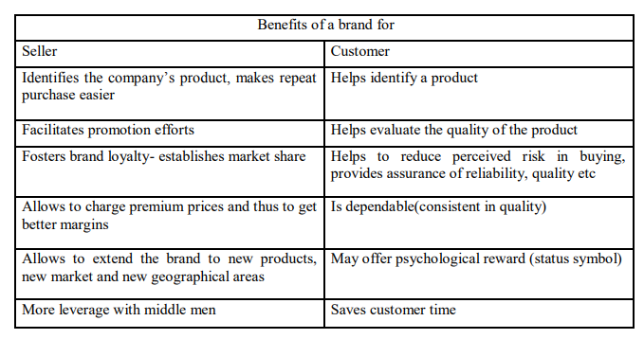
Source: (Dibb (1997), Biel (1990), Murphy (1990), Court (1997))
The measure in which brands generate values depends on how they interrelate three dimension:
- Meaningfulness: what this brands stands for, what are the values that it portraits and stand by, why people should care…
- Uniqueness: how it manages to stand out and diversify from competitors…
- Reliability: why people should trust this brand, how it manages to reassure customers of its quality…
Three simple steps to reignite your market competiveness:
- Study your revenue and cost structure, how can you be more efficient without penalising quality?
- Exploit new opportunities from the seasonality of your commodity’s price
- Benchmark your offer to competitors’ moves on the market: plan your communication and visibility strategies accordingly
A good commodity marketing plan is simple but takes work, making it important for producers to monitor goals and revise as needed. The plan may involve other people, therefore it is important to develop relationships and set up accounts in advance. Share the plan with the individuals who will help execute it.
Contents in bullet points
- Agricultural marketing is a process which starts with a decision to produce a saleable farm commodity, involves all the aspects of market structure or system, both financial and institutional, based on technical and economic considerations, and includes pre- and post-harvest operations, assembling, grading, storage, transportation and distribution. Agricultural marketing plays an important role not only in stimulating production and consumption, but also in accelerating the pace of economic development. It is the most important multiplier of agricultural development. In the process of shifting from traditional to modern agriculture, marketing emerges as the biggest challenge because of production surpluses generated by the shift

- Your challenge as a Digital Leader would be to avoid competing on price and to stand out - especially when product distinction is minimal, you have to differentiate from alternatives so consumers will select your brand over others.
5 glossary entries
Digital Leader: manager who understands how technologies can most effectively enhance the qualities of human capital.
Commodity: It is a basic good used in commerce that is interchangeable with other goods of the same type. Commodities are most often used as inputs in the production of other goods or services.
Branding: It is the process of giving a meaning to specific organization, company, products or services by creating and shaping a brand in consumers’ minds. It is a strategy designed by organizations to help people to quickly identify and experience their brand, and give them a reason to choose their products over the competition’s, by clarifying what this particular brand is and is not.

SEO: It stands for search engine optimization, which is a set of practices designed to improve the appearance and positioning of web pages in organic search results. Because organic search is the most prominent way for people to discover and access online content, a good SEO strategy is essential for improving the quality and quantity of traffic to your website.

Seasonality: It is a characteristic of a time series in which the data experiences regular and predictable changes that recur every calendar year. Any predictable fluctuation or pattern that recurs or repeats over a one-year period is said to be seasonal.
Bibliography and Further References
FAO, Commodity Marketing, https://www.fao.org/3/w3240e/w3240e06.htm;
Agricultural Marketing: Concept and Definitions, http://jnkvv.org/PDF/10042020083748concept%20of%20ag%20markeing_EgEcon530.pdf
Mridanish Jha, Effective marketing strategy for branding a commodity with special reference to consumer goods,
How to brand sand, https://www.strategy-business.com/article/16333
Acharya, S.S. and N.L. Agarwal (2011), Agricultural Marketing in India, Oxford &IBH publishing Company Pvt Ltd., Fifth edition.
Singh, Hardeep, M.K. goel, and A.K. Singhal (2012), Challenges in Rural and Agriculture Market, VSRD International Journal of Business & Management Research, Vol. 2 (6), pp. 299-304

Thomas von der Fuhr, Commodity Branding – the Ultimate Marketing Challenge, https://www.linkedin.com/pulse/commodity-branding-ultimate-marketing-challenge-thomas-von-der-fuhr/
5 multiple-choice self assessment questions
1) SWOT Analysis stands for: Strengths, Weaknesses, Opportunities and Trends.
TRUE √ - FALSE
2) A business plan is
a. an essential written document that provides a description and overview of your company's future √
b refers to a financial statement that reports a company's assets, liabilities, and shareholder equity at a specific point in time
3) Local Digital marketing is:
a. a way to sell products of your farm on site; √
b. a tool available onlne for e-commerce
4) Commodity Marketing
a. is commonly used in reference to basic agricultural products that are either in their original form or have undergone only primary processing. √
b. refers to the finished product;
5) In your Commodity Marketing Strategy
a. you can only compete with the price
b. you can start a branding campaign to make the product unique √
Related Material | //
Related PPT
Reference Link | //
Video in YouTube format (if any) | //

